

**Fig S1.** Proposed 4´-hydroxyflavone and 4´-deoxyflavone pathway with structures of glycosylated flavones included. Enzyme names in blue are specific isoforms that have been identified in *S. baicalensis*, and enzyme names in black are general names. Flavones that were quantified have names in bold and are numbered to match the labeling of Figure 2.

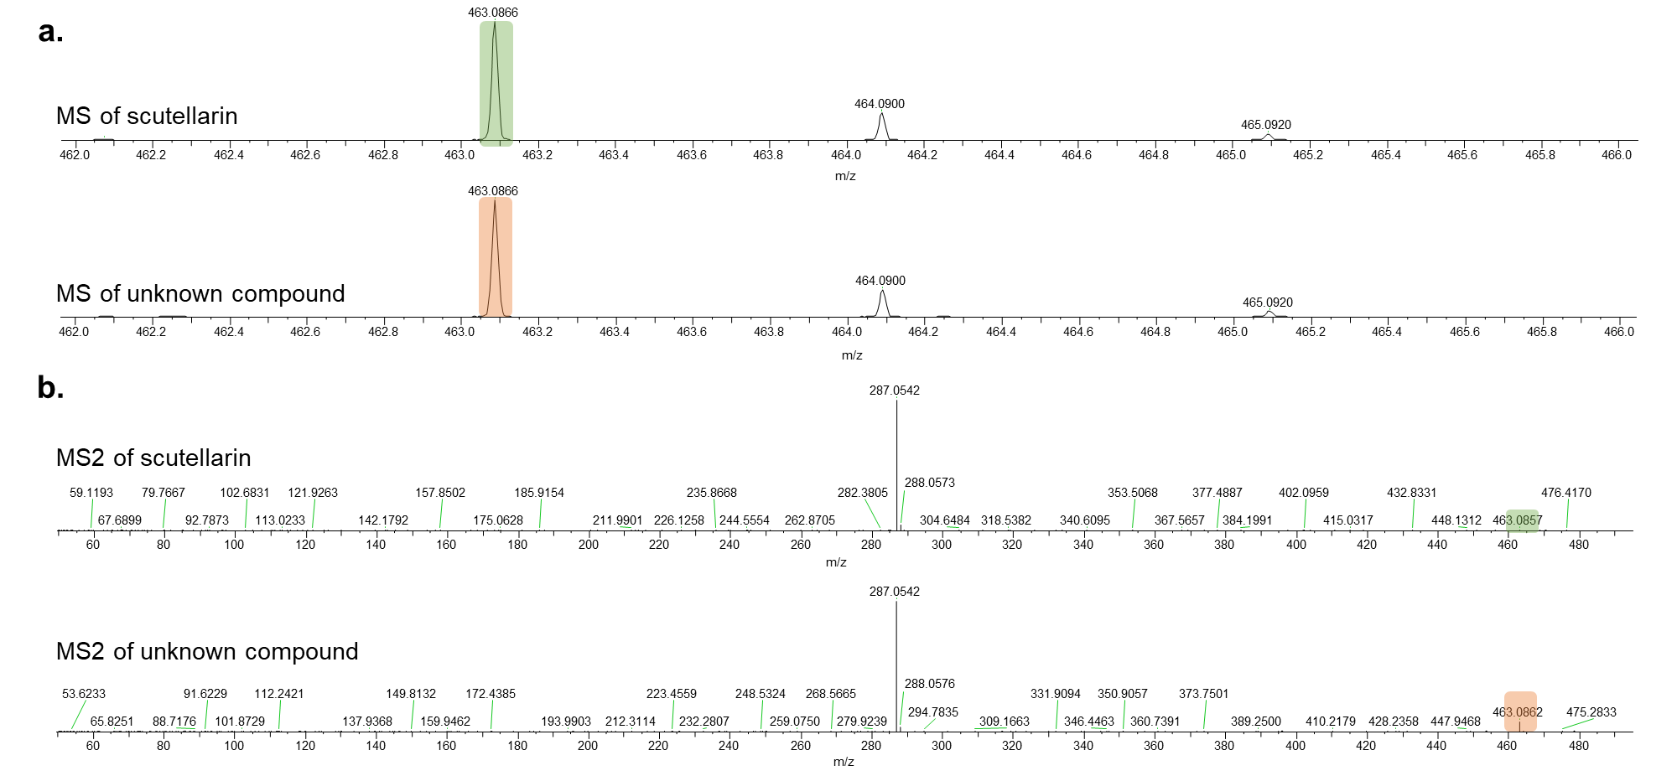

**Fig S2.** MS (a), and MS/MS (b) spectra of standard scutellarin and unknown compound.

**Fig S3**. 1H NMR spectrum of isolated compound (600 MHz, DMSO-d6). Water signals were suppressed by presaturation.

**Fig S4.** 13C NMR spectrum of isolated compound (151 MHz, DMSO-d6).

a.

b.

c.

d.

**Fig S5**. 2D NMR spectra of isolated compound. **a:** 1H-1H COSY; **b**: HSQC; **c:** HMBC; **d**: 2D-NOESY. Positive and negative contours are highlighted in black and green, respectively.

**Fig S6.** Proposed pathway for biosynthesis of isoscutellarein 8-glucuronide in *Scutellaria*.

**Table S1**. Comparison of 1H (600 MHz, DMSO-d6) chemical shifts of unknown compound and scutellarin.

|  |  |  |
| --- | --- | --- |
|  | Unknown compound | Scutellarin1 |
| Position | δH (type, mult, *J* in Hz) | δH (type, mult, *J* in Hz) |
| **3** | 6.83 (1H, s) | 6.82 (1H, s) |
| **5** | 12.82 (OH, br, s) | 12.74 (1H, br s) |
| **6** |  | 8.59 (OH, br s) |
| **7** |  |  |
| **8** |  | 6.99 (1H, s) |
| **2'** | 8.07 (2H, d, *J* = 8.64 Hz) | 7.93 (2H, d, *J* = 9.0 Hz) |
| **3'** | 6.93 (2H, d, *J* = 8.64 Hz) | 6.98 (2H, d, *J* = 9.0 Hz) |
| **4'** | 10.34 (OH, br, s) | 10.36 (1H, br s) |
| **5'** | 6.93 (2H, d, *J* = 8.64 Hz) | 6.98 (2H, d, *J* = 9.0 Hz) |
| **6'** | 8.07 (2H, d, *J* = 8.64 Hz) | 7.93 (2H, d, *J* = 9.0 Hz) |
| **1''** | 4.82 (1H, d, *J* = 7. 86 Hz) | 5.22 (1H, d, *J* = 7.2 Hz) |
| **2''** | 3.49 (1H, t, *J* = 8.58 Hz) |  |
| **3''** | 3.35 (1H, t, *J* = 9.06 Hz) |  |
| **4''** | 3.51 (1H, t, *J* = 9.6 Hz) |  |
| **5''** | 3.82 (1H, d, *J* = 9.66 Hz) | 4.05 (1H, d, *J* = 9.6 Hz) |

**Table S2**. Comparison of 1H (600 MHz, DMSO-d6) and 13C (151 MHz, DMSO-d6) chemical shifts of unknown compound and isoscutellarein 8-*O*-β-glucuronopyranoside2.

|  |  |  |  |  |
| --- | --- | --- | --- | --- |
|  | Unknown compound | | Isoscutellarein 8-*O*-β-glucuronopyranoside | |
| Position | δC | δH (type, mult, *J* in Hz) | δC | δH (type, mult, *J* in Hz) |
| **2** | 163.86 |  | 163.80 |  |
| **3** | 102.33 | 6.83 (1H, s) | 101.60 | 6.76 (1H, s) |
| **4** | 181.72 |  | 181.40 |  |
| **5** | 156.90 | 12.82 (OH, br, s) | 156.50 | 12.74 (1H, br s) |
| **6** | 98.86 | 6.29 (1H, s) | 99.40 | 6.56 (1H, s) |
| **7** | 157.23 | 5.44 (OH, br, s) | 156.50 |  |
| **8** | 125.11 |  | 125.30 | 6.99 (1H, s) |
| **9** | 149.19 |  | 148.80 |  |
| **10** | 103.35 |  | 102.60 |  |
| **1’** | 120.96 |  | 120.70 |  |
| **2'** | 128.85 | 8.07 (2H, d, *J* = 8.64 Hz) | 128.50 | 8.40 (2H, d, *J* = 8.0 Hz) |
| **3'** | 115.96 | 6.93 (2H, d, *J* = 8.64 Hz) | 115.70 | 7.48 (2H, d, *J* = 8.0 Hz) |
| **4'** | 161.12 | 10.34 (OH, br, s) | 160.80 | 10.36 (1H, br s) |
| **5'** | 115.96 | 6.93 (2H, d, *J* = 8.64 Hz) | 115.70 | 7.48 (2H, d, *J* = 8.0 Hz) |
| **6'** | 128.85 | 8.07 (2H, d, *J* = 8.64 Hz) | 128.50 | 8.40 (2H, d, *J* = 8.0 Hz) |
| **1''** | 106.25 | 4.82 (1H, d, *J* = 7. 86 Hz) | 106.10 | 5.07 (1H, d, *J* = 7.6 Hz) |
| **2''** | 73.69 | 3.49 (1H, t, *J* = 8.58 Hz) | 73.10 | 4.31 (1H, overlapped) |
| **3''** | 75.20 | 3.35 (1H, t, *J* = 9.06 Hz) | 76.70 | 4.31 (1H, overlapped) |
| **4''** | 71.41 | 3.51 (1H, t, *J* = 9.6 Hz) | 71.80 | 4.35 (1H, m) |
| **5''** | 76.00 | 3.82 (1H, d, *J* = 9.66 Hz) | 75.50 | 4.19 (1H, d, *J* = 8.8 Hz) |
| **6’’** | 169.96 |  | 173.80 |  |

**Table S3**. Voucher information for the species used in this study.

|  |  |
| --- | --- |
| Species | Voucher Number |
| *S. altissima* | FLAS 275373 |
| *S. baicalensis* | FLAS 275374 |
| *S. barbata* | FLAS 275375 |
| *S. parvula* | FLAS 275376 |
| *S. racemosa* | FLAS 275377 |
| *S. tournefortii* | FLAS 275380 |
| *S. wrightii* | FLAS 275381 |

References:

1 Jiang Z, Yang J, Jiao Y *et al.* Determination of scutellarin in breviscapine preparations using quantitative proton nuclear magnetic resonance spectroscopy. *J Food Drug Anal* 2016; **24**: 392–398.

2 Billeter M, Meier B, Sticher O. 8-hydroxyflavonoid glucuronides from *Malva sylvestris*. *Phytochemistry* 1991; **30**: 987–990.